Weathering, Erosion, and Homes

Weathering, erosion, and deposition is a constant issue for many homes. Some areas have rapid changes in temperature which could easily cause cracks in certain walls. Some areas on near shores and have issues with erosion. Other areas are near the base of hills and have to worry about build-up of sediment from uphill.

You have found 2 relatively equal dream homes for sale, one here in Maryland, one in Florida, outside of Orlando. Take a look at each home. Using information about the regions, as well as the images, identify what potential weathering, erosion, and deposition problems each home might have. Each home may not have examples of all three, but you should find at least 4 total examples.

After you have analyzed the two homes, write a well written paragraph explaining why you might choose one over the other. Your paragraph MUST include the evidence from your examples, but you may say that it is worth the risk. For this assignment, assume you would want to live in one of these areas (don’t say that you prefer California and simply wouldn’t move to either, even though it may be true).

Home 1:

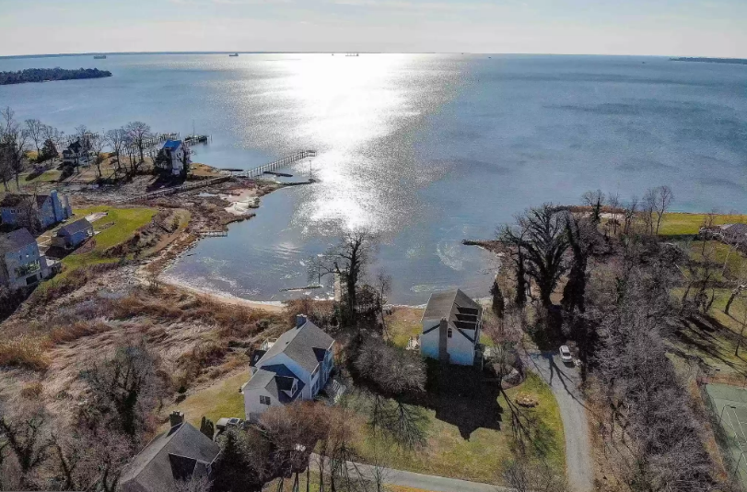Location: Maryland

Price: $1,500,000

Description: Waterfront property. Close to the city with plenty of shopping. Great for Navy! Recreational boating and kayaking.

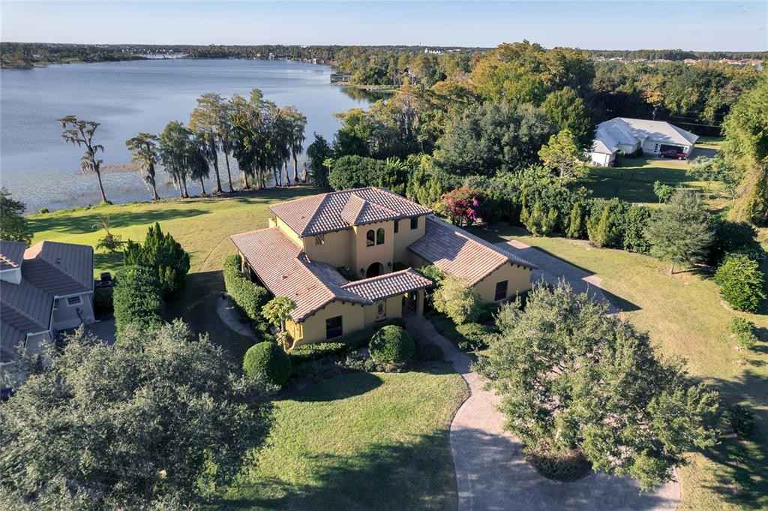Home 2:

Location: Florida

Price: $1,445,000

Description:

This stunning 4 Bed - 3 Bath Home sits on an oversized lot with 100ft +/- of lake frontage on the Lake Sawyer with incredible views of the sunset. Iron Gates open to a beautiful courtyard that leads to the main entry. Home is near Disney and Orlando. Plenty of nearby shopping and attractions. Tons of small recreational lakes. Home WILL NOT LAST LONG!

([hint](https://foundationtechs.com/sinkhole-map/))

|  |  |  |  |
| --- | --- | --- | --- |
|  | Potential Weathering Issues? | Potential Erosion Issues? | Potential Deposition Issues? |
| Home 1 |  |  |  |
| Home 2 |  |  |  |

Write a well written paragraph about why you would choose one home over the other. Reminder that it must include the evidence you provided, though you may say that the risk is worth living in that area. You must assume that you would want to live in one of those homes, even if you would prefer something else.